# Sprint 00

End of the first week of Sprint 00 - Storyboard:

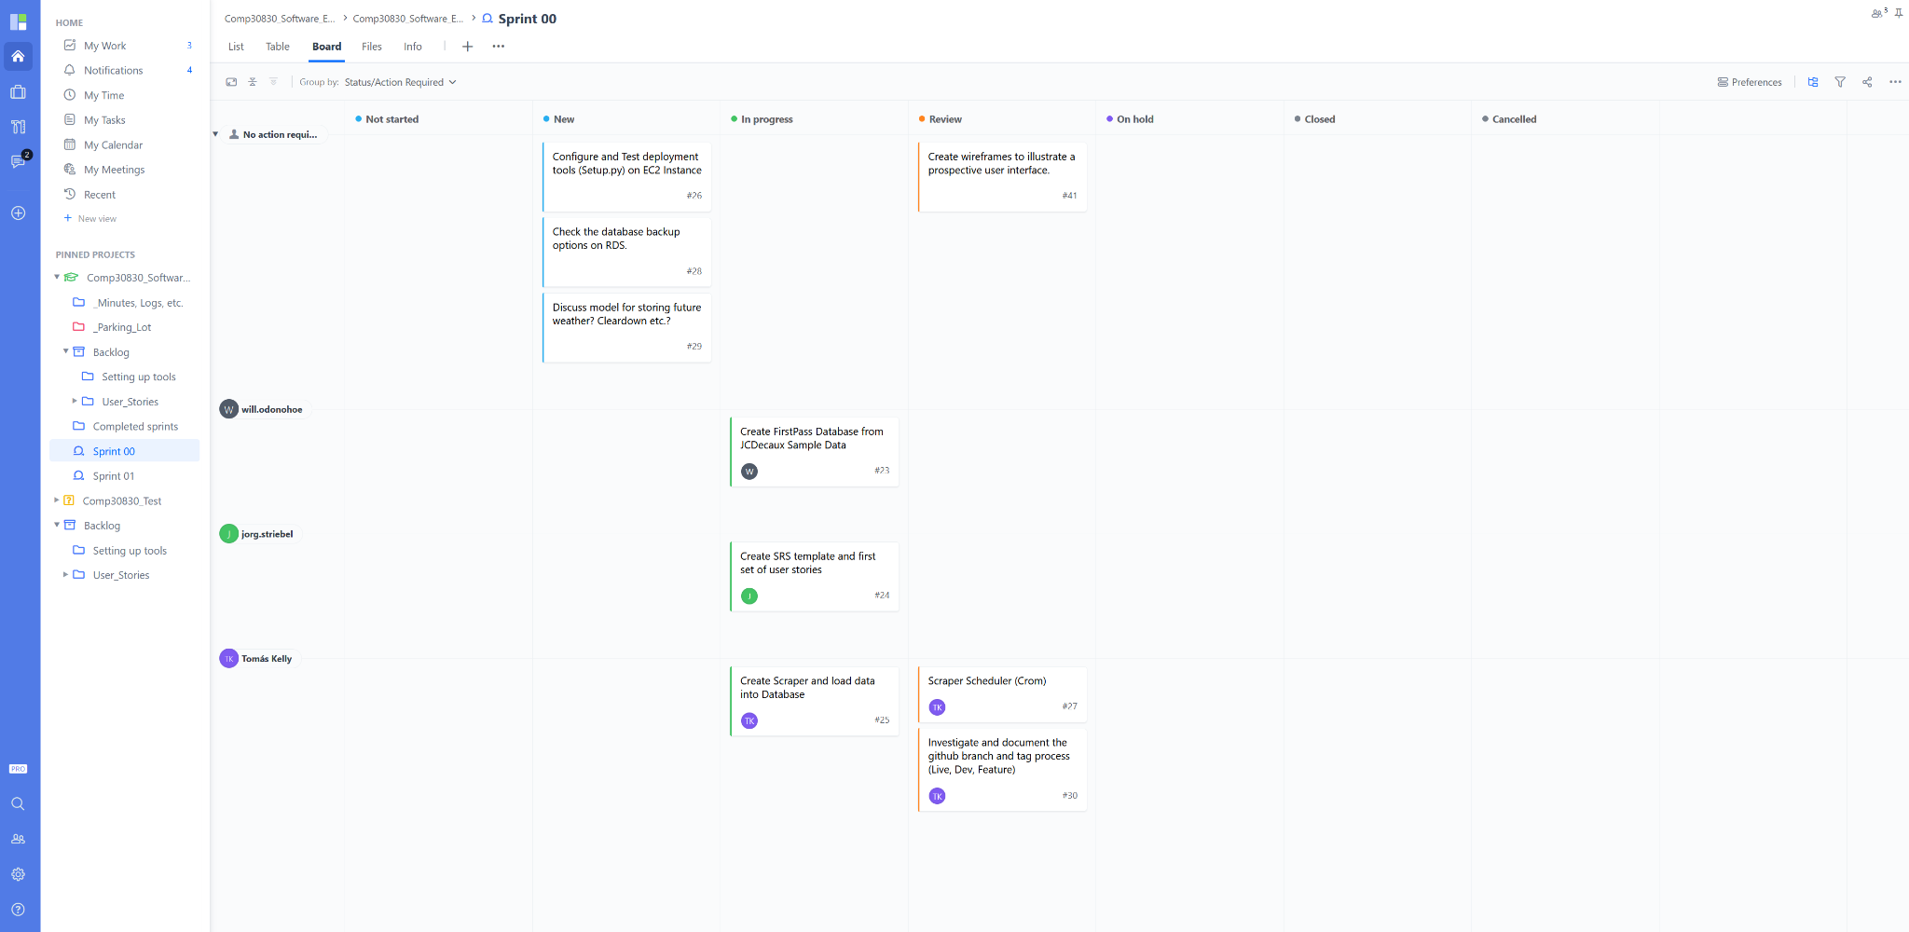

End of Sprint 00 - Storyboard:

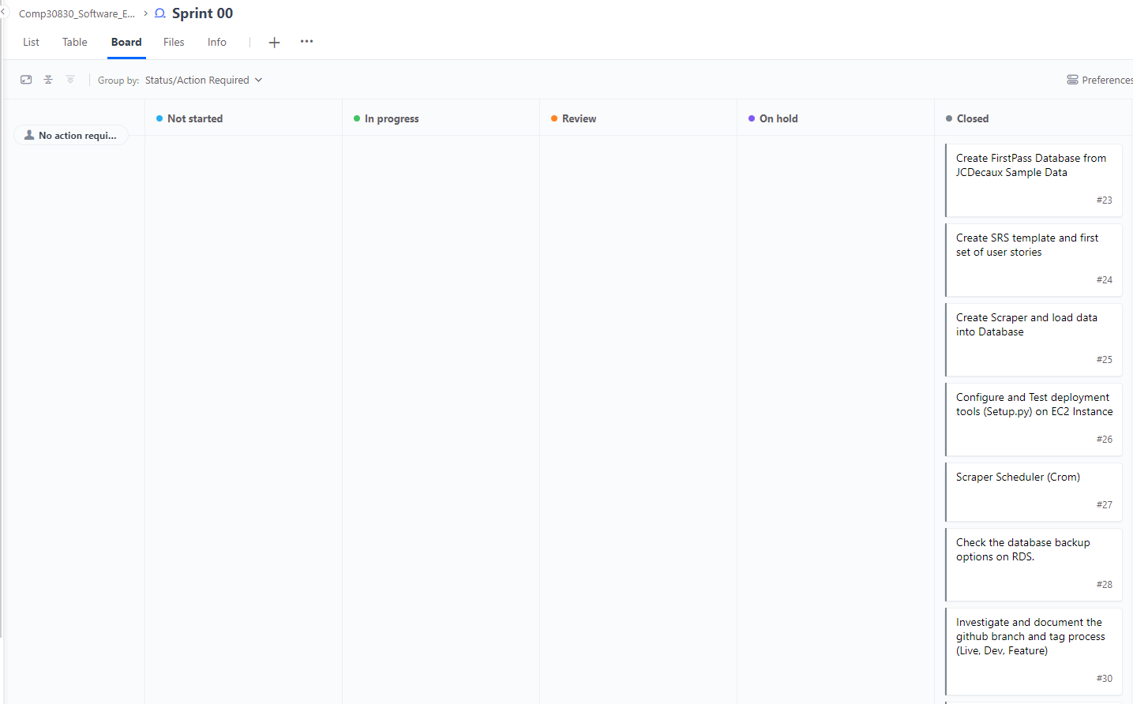

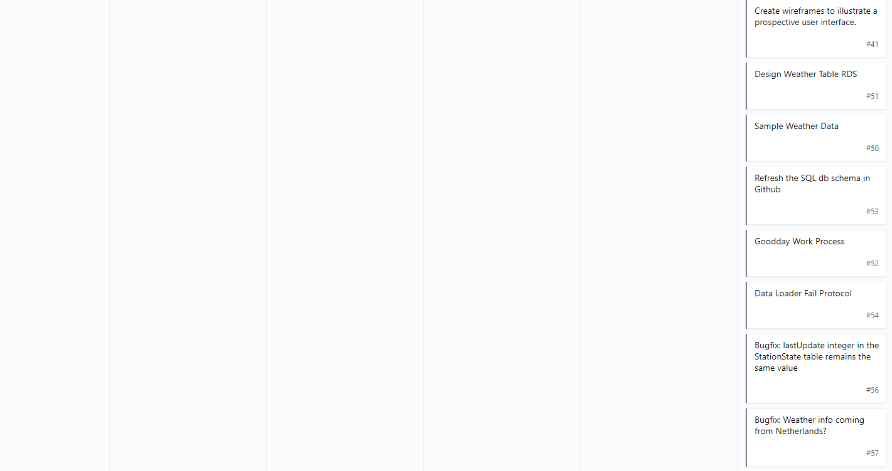

Sprint 00 Burndown:

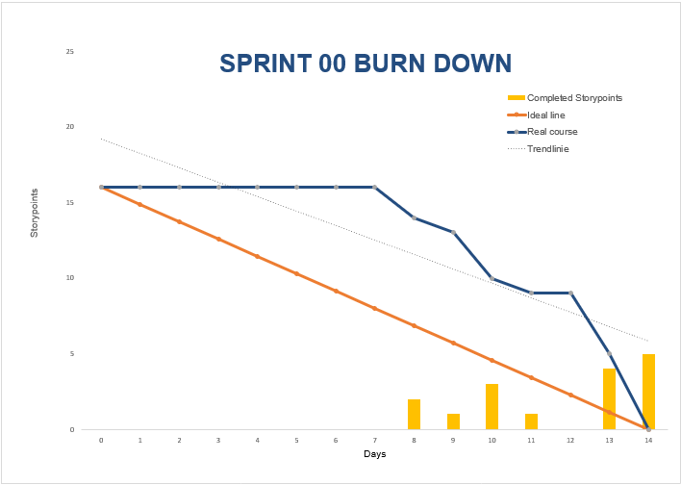

# Sprint 01

Start of Sprint 01 - Storyboard:

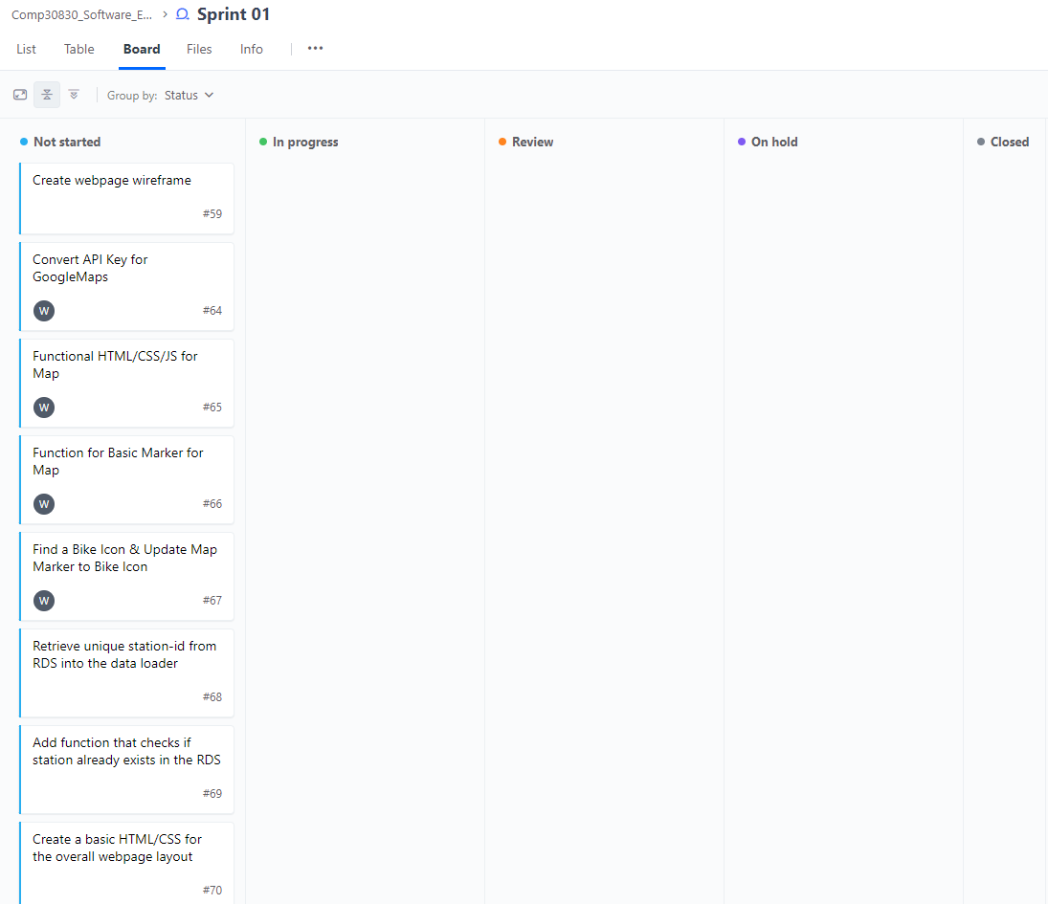

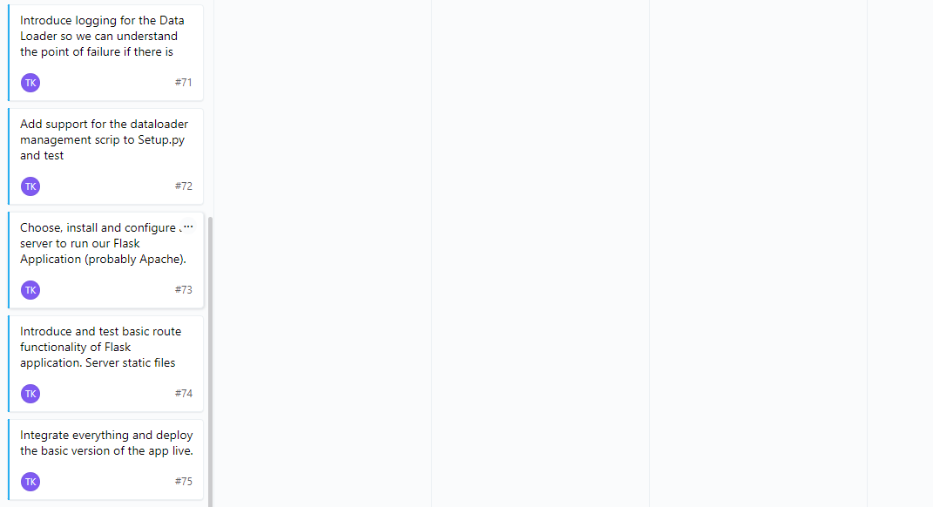

End of the first week of Sprint 01 - Storyboard:

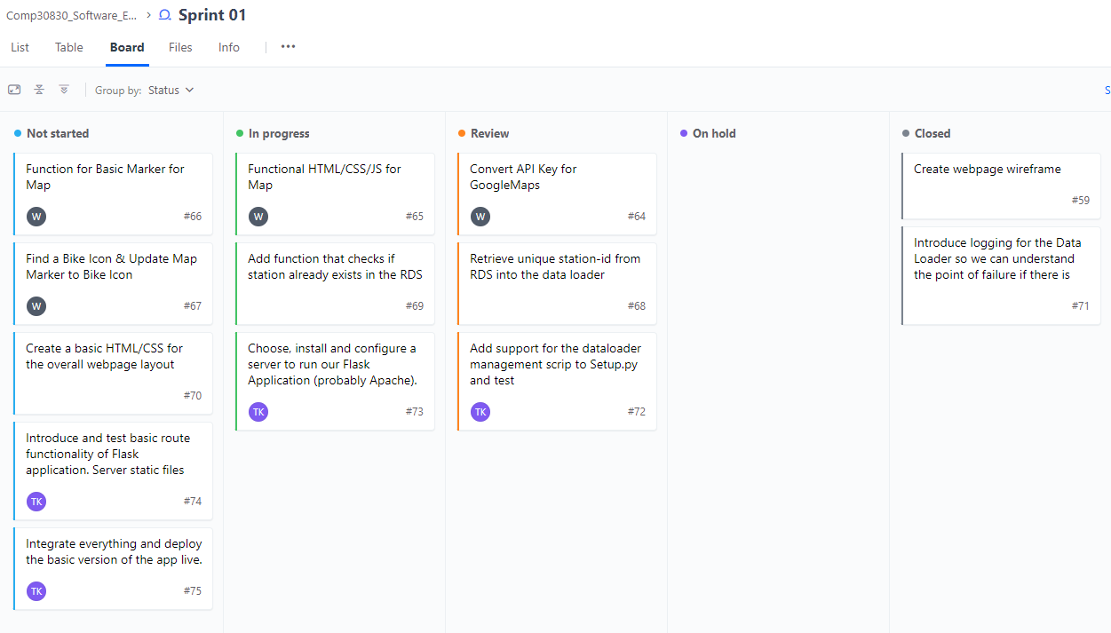

End of Sprint 01 - Storyboard:

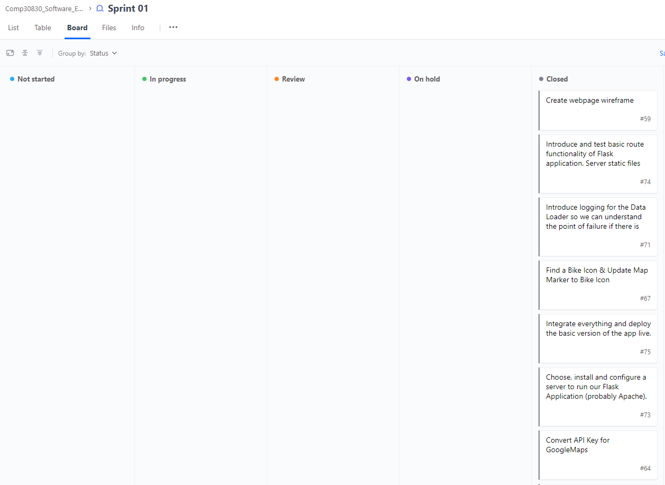

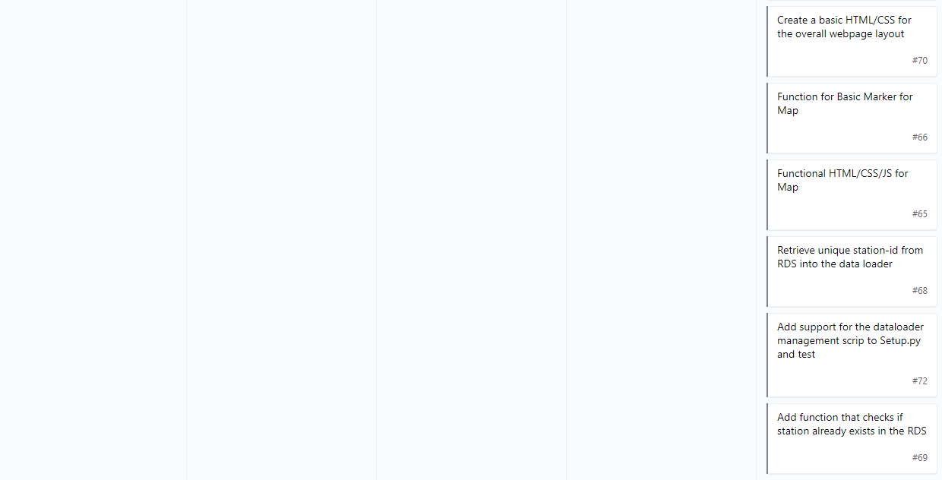

Sprint 01 Burndown:

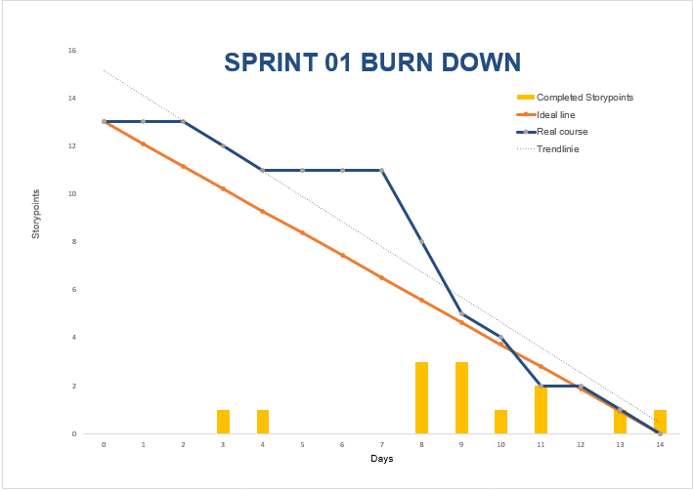

# Sprint 02

Start of Sprint 02 - Storyboard:

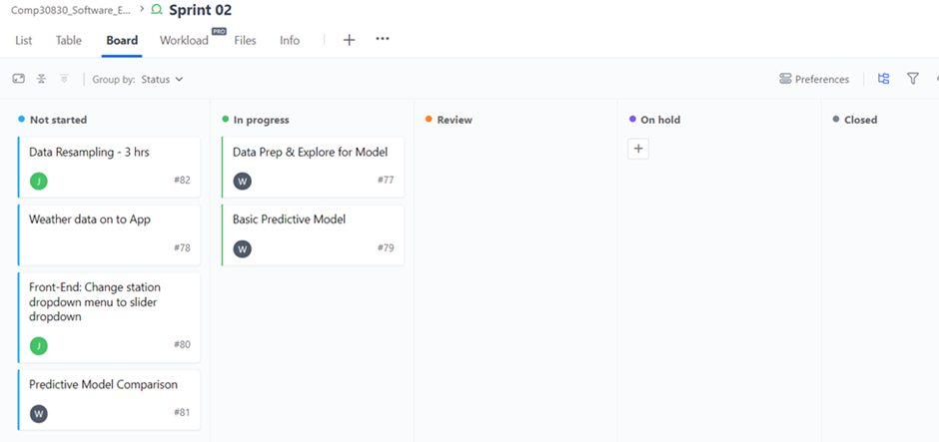

End of the first week of Sprint 02 - Storyboard:

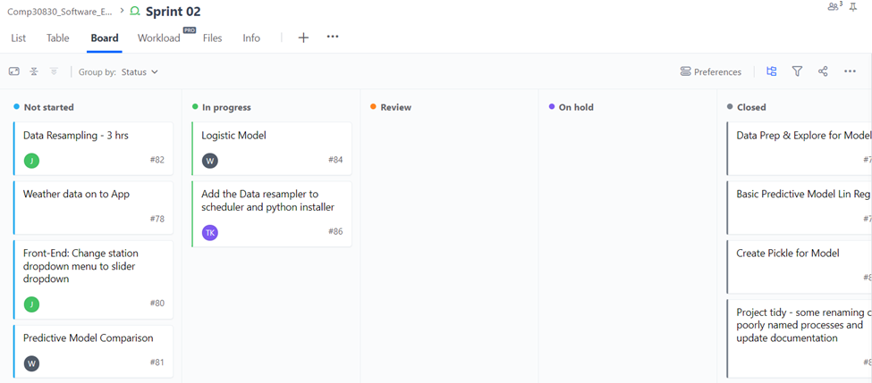

End of Sprint 02 - Storyboard:

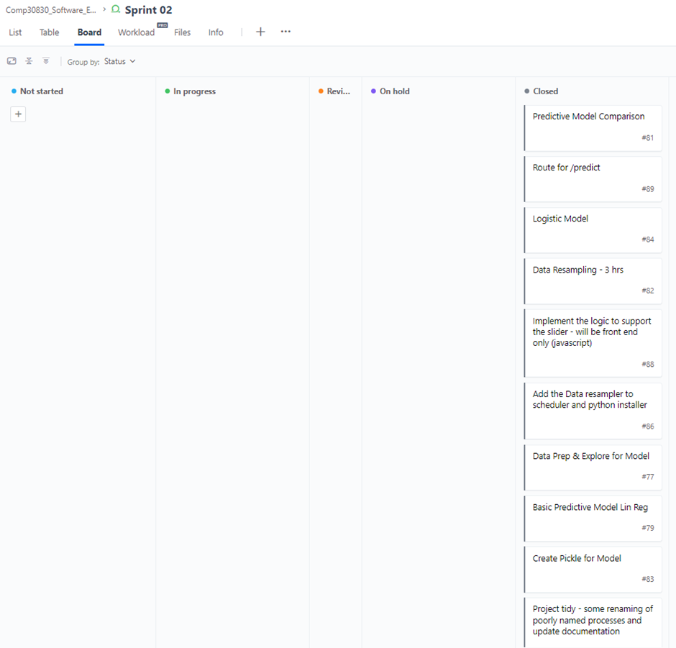

Sprint 02 Burndown:

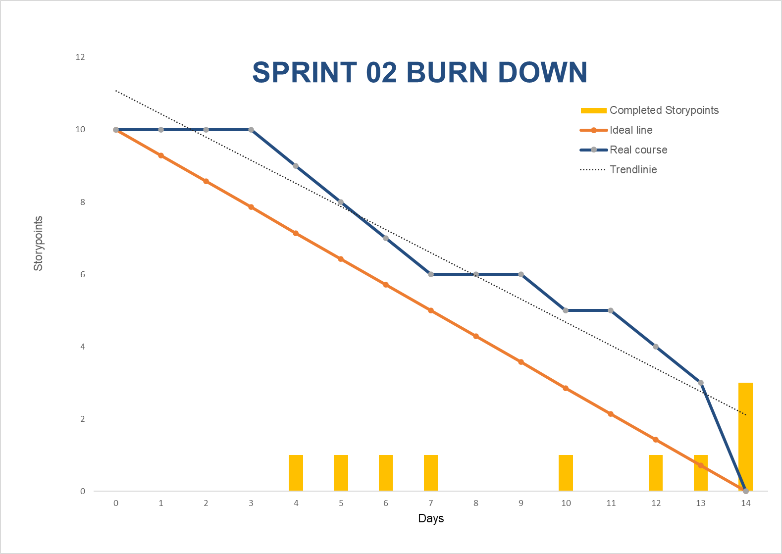

# Sprint 03

Start of Sprint 03 - Storyboard:

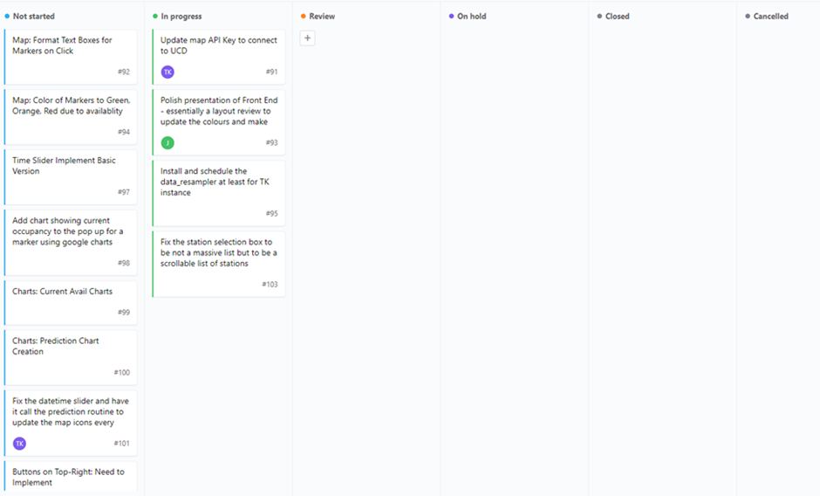

End of the first week of Sprint 03 - Storyboard:

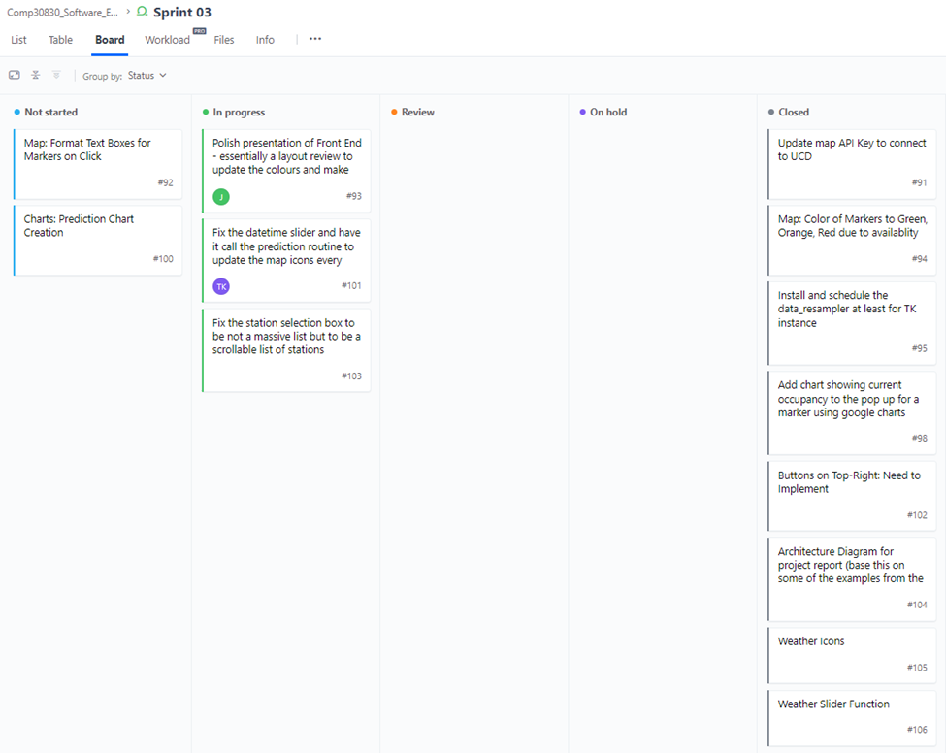

End of Sprint 03 - Storyboard:

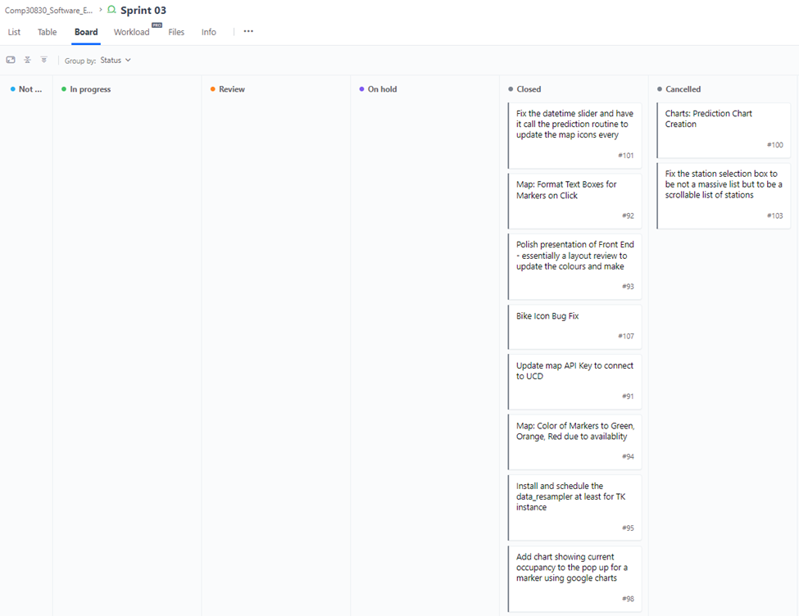

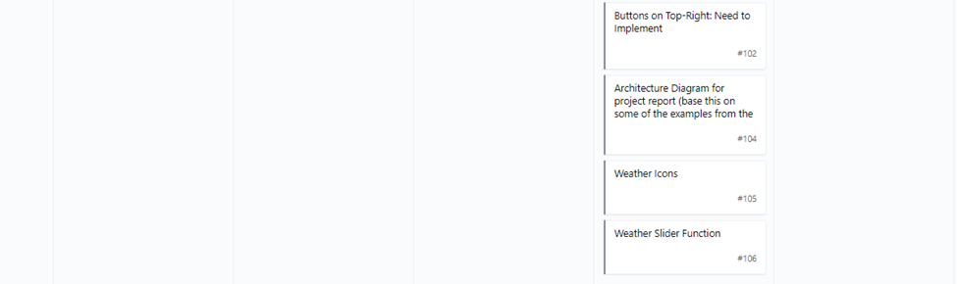

Sprint 03 Burndown:

